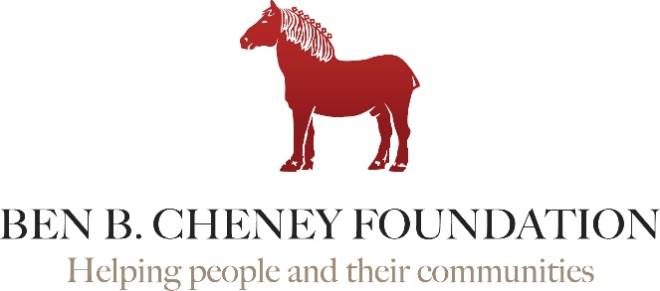

3-Pronged Application Process

Step
1

Letter of Inquiry
Letters of inquiry are a way for organizations to tell their story and for the Foundation to evaluate its interest. There are no deadlines. The Foundation accepts LOIs throughout the year.
While the Foundation responds promptly, it may take 6-9 months from the receipt of a letter to an application’s review by the board of directors. The board meets 4xs each year.
Step
2

Foundation Meeting
If the project outlined in a LOI appears to fit the Foundation’s grant making plans, the Foundation will schedule a site visit or an office meeting with Foundation staff.
The Foundation appreciates face-to-face meetings, whenever possible. This meeting allows staff to get to know you and gain more information about the project and your organization.
Step
3

Formal Application
The meeting with the Foundation usually results in scheduling a formal application. Our staff will initiate the invitation to apply.
Large Grant Program - Grant proposals over $15,000 must go to a full board meeting. While the Foundation seeks to be timely, it also must balance the volume of requests with the timing of projects and funds available.
Small Grant Program - Grant proposals less than $15,000 are processed outside of a formal board meeting. Often such grants can be reviewed in as little as one to two months.

Priorities

The Cheney Foundation made major pivots during 2020 to respond quickly to emergency needs faced by our grantees by providing many operational grants. These grants were outside the Foundation’s norm. During 2022, we have returned primarily to our favored priorities - investing in equipment or facilities that will have a longstanding impact on community needs. With the downturn in the economy, our endowment has dropped significantly. As we look into 2023, we don’t see a rebounding in the near future. This will impact our giving totals and may or may not shift priorities again.

Staff Participants

Erika Tucci
Senior Program Officer
253.572.2442
erika@benbcheneyfoundation.org

Carol Lewis
Grants Manager &
Executive Assistant
253.572.2442
carol@benbcheneyfoundation.org

www.benbcheneyfoundation.org

